**Salesforce CRM Implementation Documentation**

**Project Name:** HandsMen Threads CRM System  
**Submitted By:** Umangi Nigam  
**Date:** 26-07-2025

**Project Overview**

HandsMen Threads, a fashion company, has adopted a Salesforce CRM solution to consolidate customer information, automate order processing, track inventory levels, and improve marketing interaction. The CRM system was designed specifically to enhance operational efficiency, maintain data integrity, and facilitate individualized customer service. Key functions include automated order acknowledgments, tracking loyalty status, inventory alerting in real time, and managing campaigns.

**Objectives**

The implementation of Salesforce CRM was primarily intended to digitize and bring into harmony the customer relationship lifecycle for HandsMen Threads. Combining order management, inventory tracking, loyalty schemes, and marketing campaigns into Salesforce gives the system a capacity to:

* Automate processes to enhance customer satisfaction.
* Optimize internal workflows and inventory control.
* Derive insights from dashboards and reports.
* Ensure scalability for future digitalization.

**Phase 1-Requirement Analysis & Planning**

**Understanding Business Requirements:**

* Manual order confirmation delayed customer communication.
* Difficulty in tracking customer loyalty and repeat purchase behavior.
* Due to an absence of stock alerts, several sales opportunities are missed.
* Campaign timelines and performance were never centrally tracked.

**Defining Scope and Objectives of the Project:**

* Central storage of customer, order, and product data.
* Automated workflows for order confirmation and loyalty updates.
* Inventory monitoring and warehouse notifications.
* Campaign lifecycle tracking from setting to execution.

**Design Data Model and Security Model**

* Objects Created:
* HandsMen_Customer__c
* HandsMen_Product__c
* HandsMen_Order__c
* Inventory__c
* Marketing_Campaign__c

**Security Model:**

* Field-level security and role hierarchy for Sales and Warehouse teams.
* Record-level sharing via sharing rules and profile permissions.

**Phase 2: Salesforce Development - Backend & Configurations**

**Set-Up Environment & DevOps Workflow**

* Sandbox and production orgs have been configured.
* Change sets are being used for deployment.

**Customization of Objects, Fields, and Validation Rules:**

Automation Validation Rules for mandatory fields and quantity restrictions.

Flows for:

* Order Confirmation Email
* Loyalty Status Update
* Stock Alert Emails

**Apex Classes & Triggers**

* OrderAmountTrigger: Automatically calculates Total_Amount__c on order.
* ScheduleBulkOrderUpdate: Scheduled Apex class to process bulk orders at midnight.
* Asynchronous Apex (Queueable Apex used for batch updates)

**Phase 3: UI/UX Development & Customization**

**Lightning App Setup**:

Custom app "HandsMen CRM" with tabs created for all custom objects.

**Page Layouts, Dynamic Forms:**

Dynamic visibility depending on order status and stock quantity.

**User Management:**

Profiles for Admin, Sales Rep, and Warehouse Manager.

**Reports and Dashboards Reports:** Total Orders per Customer, Low Stock Alerts, Loyalty Distribution.

**Dashboards:** Daily Orders, Loyalty Tier Breakdown, Campaign Performance.

Lightning Pages & LWC Development Lightning record pages have been created for all objects.

No LWC used (optional for future enhancement).

**Phase 4: Migration, Testing, and Security**

**Loading Data:**

* Records were added through Data Loader.
* Customer records were added through Data Import Wizard.

**Data Accuracy:**

* For Stock and Loyalty fields, Field History Tracking is enabled.
* Email and phone duplicate customer records.
* Existing customer matching business rules.

**Security Configuration:**

* Admin > Sales Manager > Sales Rep: Role Hierarchy.
* Marketing Campaign access through Permission Sets.
* Cross team collaboration through Sharing Rules.

**Verification:**

* Flow triggered emails
* Inventory alert notifications
* Approval rejection processes
* Data integrity for dashboards

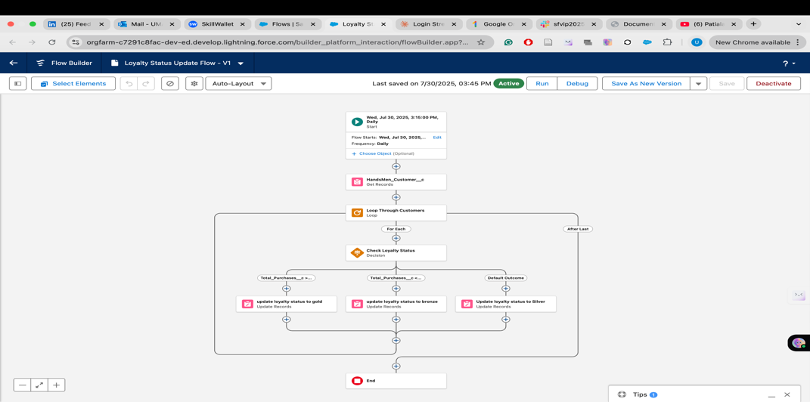

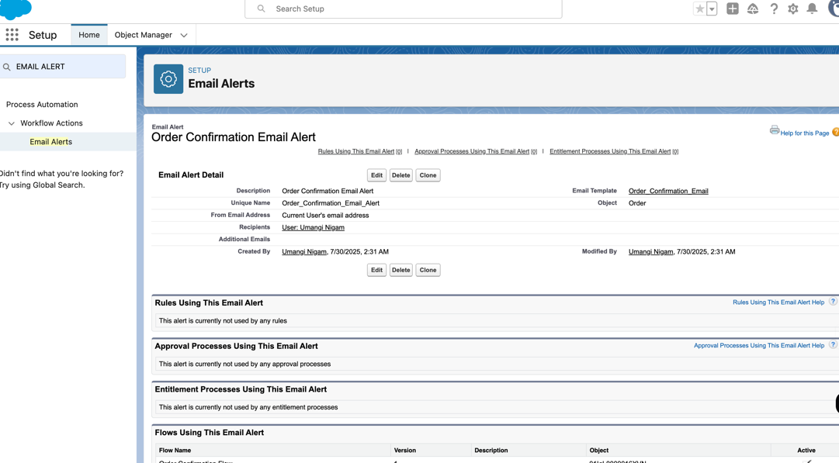

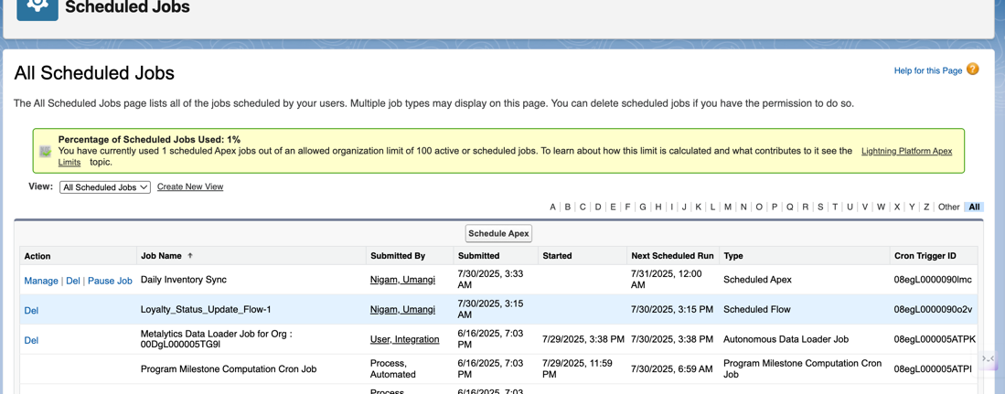

**Phase 5: Launch, Document, and Management**

**Launch Strategy :**

* Change Sets transitioned from Sandbox to Production.
* Production environment manual checks conducted after deployment.

**Management Plan :**

* Health oversight of automation logs conducted on a monthly basis.
* Warehouse supervisor oversees monitoring of inventory tracking dashboard.
* A shared Confluence space houses a collective maintenance guide.

**Reactive Strategy :**

* Apex error logs.
* Error notification emails for Flows.
* Error safeguards and handling implemented for triggers and Flows, including null conditions.

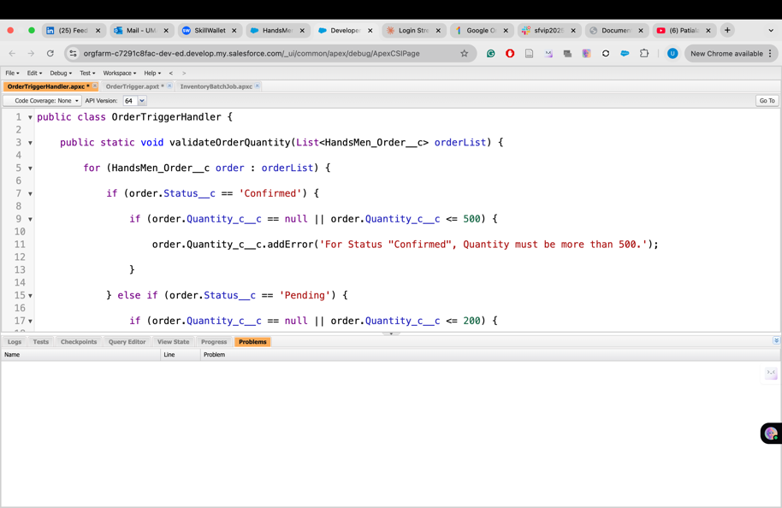

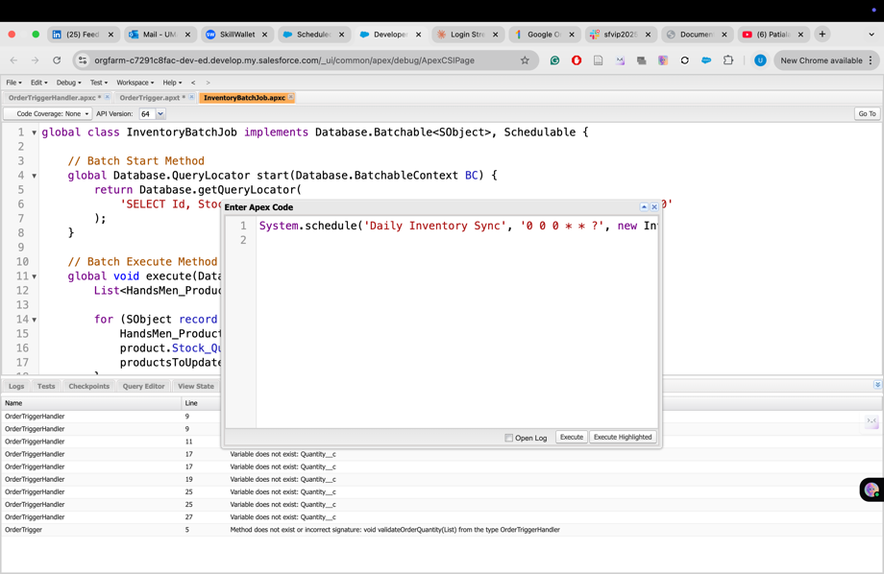

**Conclusion**

With the implementation of Salesforce CRM, the overall management system of HandsMen Threads has been transformed through automation of key processes, yielding enhanced visibility across sales, inventory, and marketing operations. The organization’s automation processes and the data architecture as handsomen threads serves as the basis of scalability for prospective advanced features like AI-powered loyalty forecasting, order tracking through chatbots, and notification via WhatsApp.

**Prospective Advanced Features**

* The integration of WhatsApp and chatbots for order tracking.
* Current AI technology enables the establishment of loyalty reward systems.
* Advanced campaigns through integration of Marketing Cloud.
* The extension of Salesforce CRM into mobile app platforms.